Order Of Service

Singing: Psalm 133-134—CW page 115

Reading: Psalm 98

Opening Hymn: TLH 8

Reading: Acts 19:1-10

Request Hymn: CW Supplement 754

Reading: Matthew 7:7-12

Sermon Hymn: TLH 436

Sermon Text: Mark 6:30-44

Feeding The Sheep

Prayer

The Apostles’ Creed, TLH page 12

Holy Communion

The Lord's Prayer

The Blessing

Closing Hymn: TLH 47

* * * * * * * * * * *

Bible Study: Lambs: Winter
Sheep: Proverbs 17:26-28
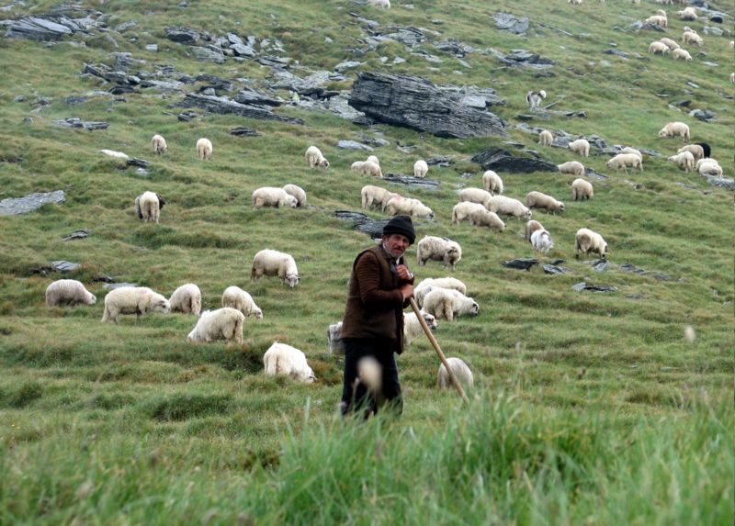

Feeding The Sheep

Water
Of
Life
19 May 2019

W A T E R O F L I F E

Independent Christian Church—Conservative Lutheran Doctrine

Worship Service: 9:30 a.m. Bible Study: 10:45 a.m.

Larry Cooper, Pastor E-Mail address:
111 N. Ridge Road lcooper@wateroflife.cc
Coon Valley, WI 54623 Web Site:
www.wateroflife.cc

* * * * * * * * * * * * * * * * * * * * * * * * * * *

Sermon Text: Mark 6:30-44

Feeding The Sheep

* * * * * * * * * * * * * * * * * * * * * * * * * * *

Mark 6:30 And the apostles gathered themselves together unto Jesus, and told him all things, both what they had done, and what they had taught.
:31 And he said unto them, Come ye yourselves apart into a desert place, and rest a while: for there were many coming and going, and they had no leisure so much as to eat.
:32 And they departed into a desert place by ship privately.
:33 And the people saw them departing, and many knew him, and ran afoot thither out of all cities, and outwent them, and came together unto him.
:34 And Jesus, when he came out, saw much people, and was moved with compassion toward them, because they were as sheep not having a shepherd: and he began to teach them many things.
:35 And when the day was now far spent, his disciples came unto him, and said, This is a desert place, and now the time is far passed:
:36 Send them away, that they may go into the country round about, and into the villages, and buy themselves bread: for they have nothing to eat.
:37 He answered and said unto them, Give ye them to eat. And they say unto him, Shall we go and buy two hundred pennyworth of bread, and give them to eat?
:38 He saith unto them, How many loaves have ye? go and see. And when they knew, they say, Five, and two fishes.
:39 And he commanded them to make all sit down by companies upon the green grass.
:40 And they sat down in ranks, by hundreds, and by fifties.
:41 And when he had taken the five loaves and the two fishes, he looked up to heaven, and blessed, and brake the loaves, and gave them to his disciples to set before them; and the two fishes divided he among them all.
:42 And they did all eat, and were filled.
:43 And they took up twelve baskets full of the fragments, and of the fishes.
:44 And they that did eat of the loaves were about five thousand men.

Psalm 23:1 The LORD is my shepherd; I shall not want. :2 He maketh me to lie down in green pastures: he leadeth me beside the still waters. :3 He restoreth my soul: he leadeth me in the paths of righteousness for his name's sake. :4 Yea, though I walk through the valley of the shadow of death, I will fear no evil: for thou art with me; thy rod and thy staff they comfort me. :5 Thou preparest a table before me in the presence of mine enemies: thou anointest my head with oil; my cup runneth over. :6 Surely goodness and mercy shall follow me all the days of my life: and I will dwell in the house of the LORD for ever.

